計算機網路概論 Homework 2 B10815057 廖聖郝

1. Packet 1: Source IP: 10.1.1.2 Source port: 6428

Destination IP: 10.1.1.1 Destination port: 9157

Packet 2: Source IP: 10.1.1.1 Source port: 9157

Destination IP: 10.1.1.2 Destination port: 6428

Packet 3: Source IP: 10.1.1.2 Source port: 6428

Destination IP: 10.1.1.3 Destination port: 5775

Packet 4: Source IP: 10.1.1.3 Source port: 5775

Destination IP: 10.1.1.2 Destination port: 6428

1. 0111100000011110

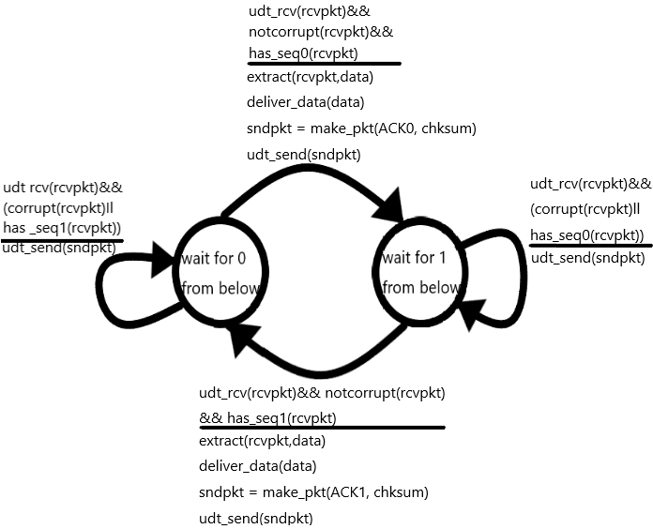

1. 0.00133

